F.4 Biology Ch.11 Transport of substances and Support in Plants

Name: _____________________ ( ) F.4__ Date: ________________

Practical 1 Demonstrating water loss from a plant by transpiration
Task: Study the demonstration on Practical 11.1 P. 11-3 and answer the following questions:
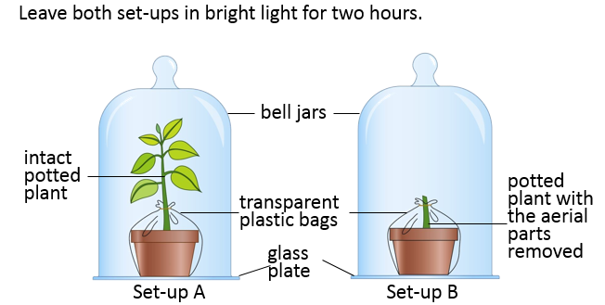
Questions for discussion:
1. Describe and explain the results in set-up A of Practical 11.1
In set-up A:
____________________ condensed on the inner wall of the bell jar.
The liquid droplets are water since it turned dry cobalt chloride paper from _________ to ____________.
This indicates that the plant loses water in form of _________________________ by transpiration. The water vapour ________________ to water on the wall of bell jar

- Why do the plants need to be well-watered before carrying out the experiment?

To ensure that the plants have obtained enough _________ for ___________________.

- What is the purpose of covering the pot and the lower part of the plant with a transparent polythene bag?

Covering the pot and the lower part of the plant with a polythene bag to ensure that the water evaporated from _____________ and the water released during the activities of ____________________________ will not affect the results of the experiment.

- What conclusion can be drawn by comparing the results of set-up A and set-up B?

________________ is released from plant in set-up A but not from plant in set-up B.
Transpiration takes place mainly in _______________________________________
Practical 2 Studying the stomatal distribution on the upper and lower surfaces of a leaf

Task | Result / Observation | Explanation / Inference
1.  (i) Adhere two pieces of dry  cobalt (II) chloride paper on  both the upper and lower  surfaces of the leaf  respectively.  (ii) Note the colour change of the  paper after some time. | The ________ surface of the leaf turns cobalt chloride paper pink first. | The _________ surface of the leaf transpires more water vapour than that of the ____________ surface.  There are ______ stomata on the lower surface of the leaf.
2.  A piece of Hibiscus leaf was immersed into hot water. | More bubbles appear on the ___________ surface of the leaf than that of the ____________ surface. | Gas in the intercellular space ____________ upon heating and is forced out through the ____________.  More gas bubbles appear on the _______ surface than on the _________ surface. This implies that the lower surface contains more ________________.
3.  (i) Paint nail varnish onto the  two surfaces of the leaf.  Let it dry.  (ii) Peel off the dried nail varnish  and observe under the microscope.  (iii) Compare the no. of stomata on both surfaces of the leaf | More _____________ are observed from the lower epidermis than that of the upper epidermis. | _______________ are the openings on the epidermis. When more stomata are present on the lower epidermis, a higher rate of __________________ is expected there.

